**Wireless Solar Charger**

**Project mentor**

Prabansh

**Project Heads**

Varun

Nihal

**Project Mentees**

Amogh

Fauzan

Fidha

Nisarg

Vennela

**Aim:**

To build a 10W portable, wireless solar lithium-ion battery charger. To harness maximum solar energy output, achieve MPPT(Max Power Point Tracking) and charge 8.4V lithium ion cells.

**Methodology:**

The project was divided into various blocks -

solar panel,

1.MPPT tracker and controller block

2.Transmitter block and inverter

3. Reciever block and rectifier

4. CCCV (Constant Current Constant Voltage) battery charger block.

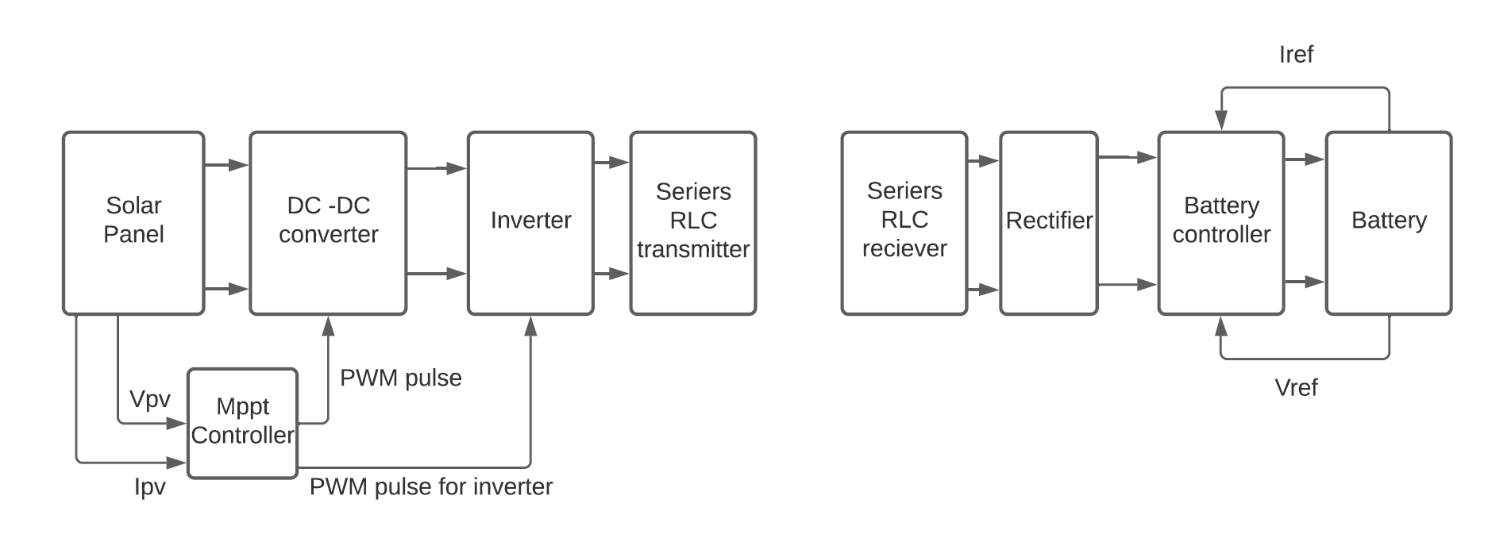

The Main Aim of this project was to build a 10 Watt Portable, Solar, Wireless Lithium Ion Charger.

To achieve this, we took the following steps:-

1. Achieve Maximum Power Point Tracking
2. Implement Wireless Transmitter and Receiver
3. Implement CCCV (Constant Current - Constant Voltage) Battery Charging

The project was divided into various blocks - solar panel, mpp tracker and controller block, transmitter block, reciever block and finally the CCCV (Constant Current Constant Voltage) battery charger block. A 10W Solar panel of short circuit current of 0.6A and open circuit voltage of 22V was chosen. The mppt tracker was implemented using a buck converter. The microcontroller - ATMEGA328P was used to provide control signals to the MPP tracker and own signals for the transmitter.

The DC was converted to AC using an inverter and tansmission of power was achieved using a series RLC circuit. The receiver block consisted of a coil for receiving power and a rectifier in the next stage. The battery controller circuit ensures a constant charging current of 1A till the li-ion battery voltage reaches 8.4V and thereafter the battery is charged while maintaining a constant voltage of 8.4V across it.

Solar Panel

We are using a 10 Watt solar panel with mppt current of 0.7amp and 20 voltage.

**Results and Simulations**

We performed a full Wireless solar charger model simulation in Simulink.

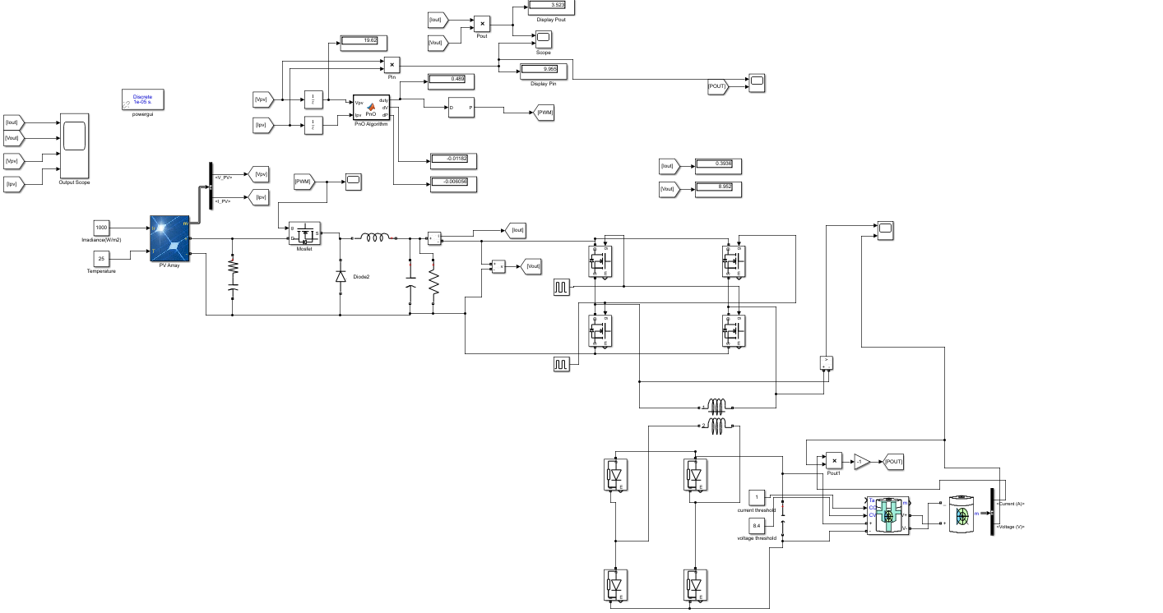

Here Yellow colour line represents the input power which slowly get saturated to 10 watt and blue colour line represents output power which saturates to 8.5 watt.

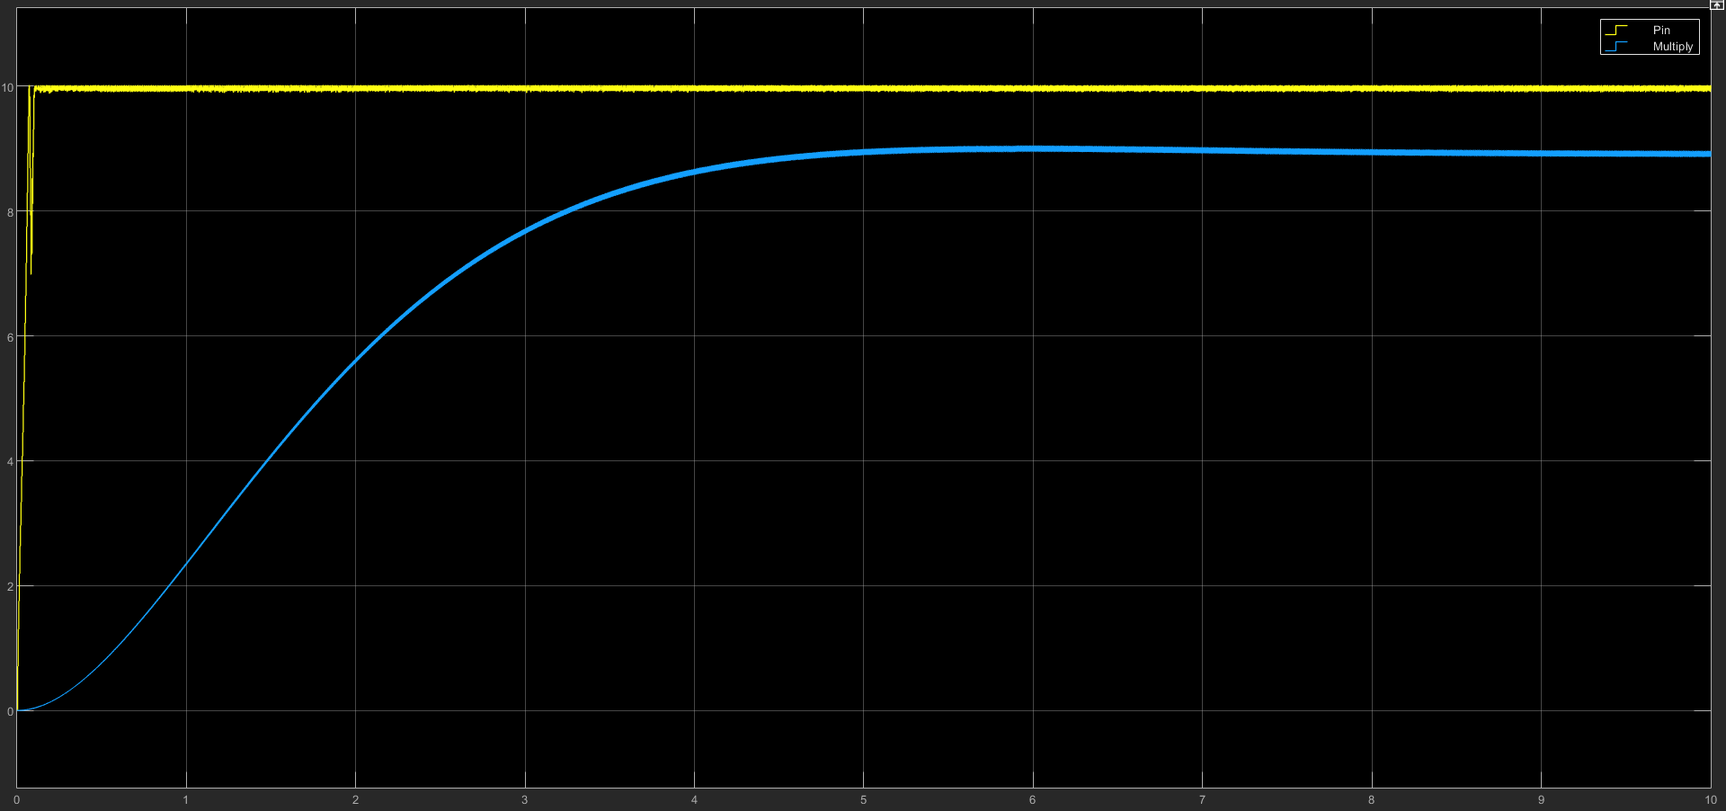

In the below figure yellow plot represents the output voltage received at receiver side which is oscillating at a frequency of 20kHz due to inverter in transmitter side.Blue line represents the output voltage of batter which is 8.4 Volt.

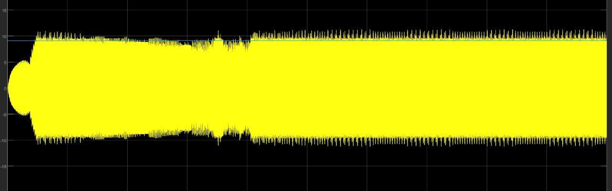

**Future Scope**

Prepare PCBs for the schematic and test the efficiency of the solar charger for different irradiance and distance between coils.